Name: Shrushti Rajanhire

Semester: III Semester

Year: 2nd Year

Subject: Database Management System BCSP2

Session: 2020-2021

Branch: Computer Science & Engineering

PROJECT TITLE:

“CAR SHOWROOM MANAGEMENT

SYSTEM”



List of Practical

|  |  |
| --- | --- |
| **Sr. No** | **Name of Practical** |
| Practical No.1 | Project Understanding, Identification of Key Performance Indicators, Identification of Modules and Sub-modules, Broad Overview of Architectural flow. |
| Practical No.2 | Project ER modeling. Use case diagram, Activity Diagram and Sequence Diagram, |
| Practical No.3 | Project Table Identifications: Table Names, Table Attributes, Primary Keys, Foreign Keys, Integrity Constraints, Data Types, Referencing Project Schema Creations: Formal joining of identified tables and checking of constraints |
| Practical No.4 | Data Entry: Data Entry on to Tables, Alteration of table structure of alteration of scheme based on requirement. Data validation against use cases and test cases |
| Practical No.5 | Data retrieval from the designed database. e.g. SELECT, Nested Queries |
| Practical No.6 | Data retrieval from the designed database. e.g. JOINS |
| Practical No.7 | Search conditions, Summary queries, Sub- queries |
| Practical No.8 | Transaction processing and Views |

**Table of Contents**

1. Practical No.1 (SRS) .…………………………………………..6

1. Introduction…………………………………………………………. 7

1.1 Purpose………………………………………………………….. 7

1.2 Scope……………………………………………………………. 7

1.3 Definitions, Acronyms and Abbreviations……………………… 7

2. References………………………………………………………… ...8

2.1 Overview…………………………………………………………8

2.2 Overall Description………………………………………………8

3. Product Perspective ………………………………………………… 9

4. Product Function……………………………………………………. 9

5. Functional Requirements…………………………………………….9

5.1 Modules………………………………………………………….9

6. System Requirements………………………………………………..10

6.1 User Interfaces…………………………………………………...10

6.1.1 Design Constraints…………………………………………10

6.1.2 Performance………………………………………………..10

6.1.3Data Storage………………………………………………..11

6.1.4Online user documentation and help system requirements ..11

6.2 Software Interfaces……………………………………………....11

6.3 Hardware Interfaces…………………………………………….. 11

6.4 Communication Interfaces……………………………………….11

2. Practical No.2…………………………………………………...12

ER diagram……………………………………………………………13

3. Practical No.3…………………………………………………...14

DDL …………………………………………………………………...14

Schema Diagram………………………………………………………16

Creation of Schema……………………………………………………17

4. Practical No.4…………………………………………………..24

Insertion of values into the schema……………………………………24

5. Practical No.5…………………………………………………...33

Data Retrieval using Select, nested queries……………………………33

6. Practical No.6…………………………………………………..37

Data Retrieval using Joins……………………………………………..37

7. Practical No.7…………………………………………………...45

Sub queries……………………………………………………………. 45

Clauses…………………………………………………………………46

Aggregate functions……………………………………………………48

ANY & ALL operator………………………………………………….50

Exist……………………………………………………………………50

8. Practical No.8…………………………………………………...60

TCL…………………………………………………………………… 60

Views…………………………………………………………………...62

**Introduction:**

SRS is a document that completely describes what the proposed software should do without describing how the software will do it. The basic purpose of SRS is to bridge the communication gap between the parties involved in the development of the software SRS is the medium through which the client and the user needs are accurately specified. A good SRS should satisfy all the parties something very hard to achieve and involves trade-offs and persuasion. Another important purpose of developing an SRS is helping the users to understand their own needs.

**Purpose:**

The purpose of this SRS document is to provide a detailed overview of our software product, its parameters and goals. This project document describes the project's target audience and its user interface, hardware and software requirements.

The purpose of the document is to collect and analyse all assorted ideas that have come up to define the system, its requirements with respect to consumers. The main purpose of this Vehicle showroom is to develop a web-based interface for Vehicle showroom companies.

The main purpose of this Online Vehicle Showroom is that it provides provision to customers to buy or book vehicles through online. The current system is offline system, in this to purchase vehicle the customer should visit to showroom. Thus, this current system is very difficult because its time consuming. Thus, our project aims at creating an web application which tracks Customer records, Online booking, Online vehicle records, etc and it provides easy to use web based interface for customers where customers can search for vehicles, view a complete details, models, features, pricing of the vehicles and book the vehicles.

This showroom system is designed for such owners and users who are interested in cars. This system keep track of all the cars along with their each and every single detail. From the date ofmanufacture to upto what price can one negotiate while taking that car, one can view all thedata here. If someone is interested in buying the car, then he/she can contact the retailer aswell for the same, via the system.

**Scope:**

The main scope of this web application is that depicts online Vehicle showroom and booking vehicle through online. Customer can register to this site and he/she can book vehicle by entering his/her login information. Administrator is main user of this system and he/she can add employees, and new vehicle details.

* The current system can be extended to allow the customers to register accounts and save favourite vehicles in to wish list.
* The design of the web application involves the listing the vehicles, search for vehicles, display the complete details of vehicles, etc.
* It provides updated information about the vehicles of all the companies.
* Customer can view Purchase details and billing records any time.

**COMMUNICATION INTERFACES**

The Online Vehicle showroom shall use the HTTP protocol for communication over the internet and for the intranet communication will be through TCP/IP protocol suite.

**PROPOSED SYSTEM:**

The proposed system is very effective. If someone is interested in buying any car, then he/she can check all the information related to the car in the given portal. He/she can even book the test drive within the system. The proposed system also helps the buyer to check which cars and companies are good for them, by showing them the past reviews about the car/companies. The proposed system is so helpful and effective.

**Abbreviations:**

|  |  |
| --- | --- |
| SRS | Software Requirement Specification |
| VS | Vehicle Showroom |
| MySQL | MySQL Database Server |
| HTML | Hypertext Mark-up Language |

**References:**

Internet References-

* [www.w3schools.com](http://www.w3schools.com)
* [www.mysql.com](http://www.mysql.com)
* [www.tutotialspoint.com](http://www.tutotialspoint.com)

**Overview:**

The following subsections provide complete overview of the SRS documentation for the product “Online Car Showroom”. The entire SRS is documented in the view of customers, dealers and admin and the following subsections are arranged to complete outlook of the software, its perspective, features, System requirements.

Vehicle showroom software is presently used in every car showrooms for computerizing entire system. This software package includes customer details , Staff details, Buying details, sales reports, maintenance details. There is no other scripting or

server end management for this system.

**Characteristics:**

1. Very Easy to Use
2. Software Manages Cars .
3. It stores Customer reports, Email Address & customer address

**Project Objectives:**

* Proper configuration of showrooms.

1. Configure each branch accurately
2. View all branches.

* To maintain the purchases of vehicles.

1. Maintain the purchases of vehicle.
2. Show all purchases of vehicle.

* To maintain the sales of vehicles.

1. Maintain the new sales.
2. View all sales of vehicle.

* To maintain the expense of showroom.

1. Manage expenses.
2. View all expenses.

* To maintain the accounts of showroom.

1. Manage accounts.
2. View accounts.

* Maintain the profit and loss of showroom.

1. Manage profit.
2. Mange loss.

* Manage the managers of showrooms.

1. Add manager.

**Software Interfaces:**

* Language Used : HTML
* Database : My SQL 5.5
* User Interface Design : HTML
* Web Browser : Google Chorme

**PRACTICAL NO.2**

**Aim:** **To create the ER-Diagram of project (Car Showroom**

**Management System)**

**Theory:**

**ENTITY-RELATIONSHIP DIAGRAM (ERD)** displays the relationships of entity set stored in a database. In other words, we can say that ER diagrams help you to explain the logical structure of databases. At first look, an ER diagram looks very similar to the flowchart. However, ER Diagram includes many specialized symbols, and its meanings make this model unique. The purpose of ER Diagram is to represent the entity framework infrastructure.

**ER Diagram: Car Showroom Management System**

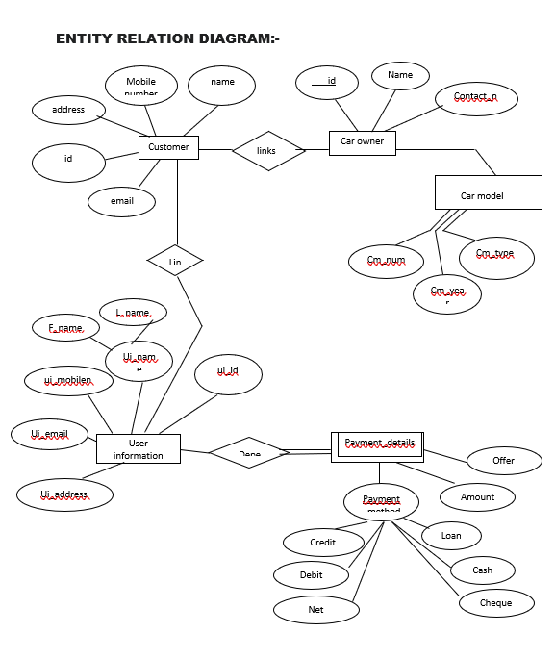

**PRACTICAL NO.3**

**Aim:** Project Table Identifications: Table Names, Table Attributes, Primary Keys, Foreign Keys, Integrity Constraints, Data Types, Referencing Project Schema Creations: Formal joining of identified tables and checking of constraints (Vehicle Showroom Management System)

**“Schema Diagram of Car Showroom Management System”** 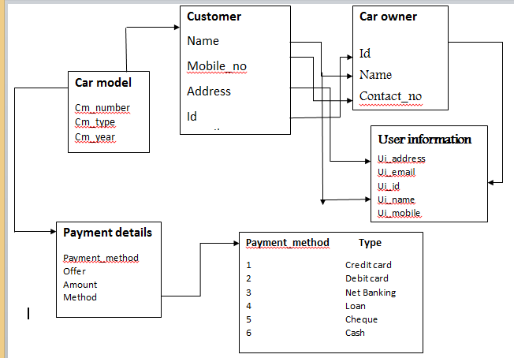

**1. Create Table Customer**

create table Customer

(

Mobile_no BIGINT ,

name char(30) ,

id varchar(100) ,

email varchar(100),

Address varchar(50),

Primary key(id)

);

select * from Customer;

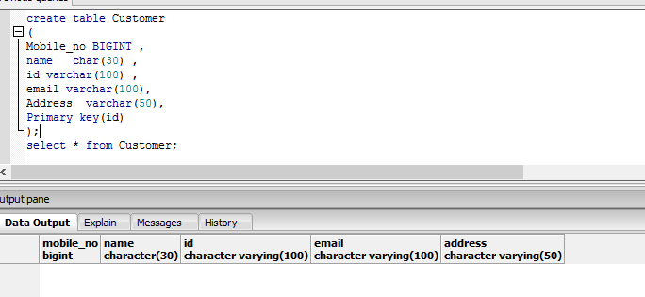

**2. Create table Car_owner**

create table Car_owner

(

Contact_no BIGINT ,

name char(30) ,

id varchar(100)

);

select * from Car_owner;

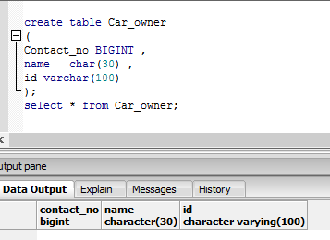

**3. Create table Car_model**

create table Car_model

(

cm_number varchar ,

cm_year int ,

cm_type char(50)

);

select * from Car_model;

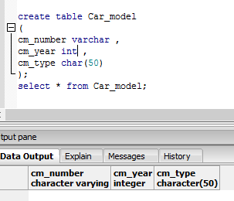

**4. Create table user_info**

create table user_info

(

ui_address varchar ,

mobile_no int ,

email varchar,

ui_id varchar,

ui_name char

);

select * from user_info;

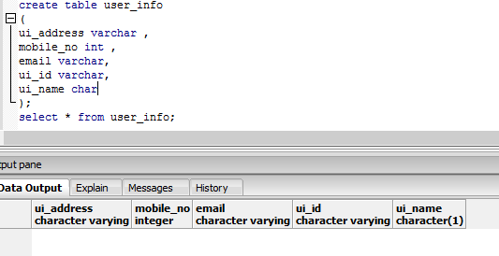

**5.Create table Payment**

Create table payment

(

Offer varchar,

Amount int,

Method int,

Foreign key (Method)references payment_type

);

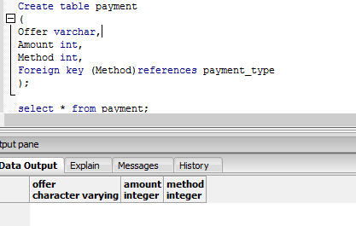

**6. Create table Payment type**

create table payment_type

(

payment_no int primary key,

payment_type char(6)

);

Select * from payment_type;

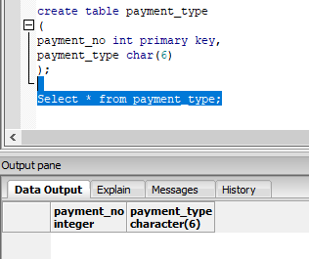

**PRACTICAL NO.4**

**Aim:** Data Entry: Data Entry on to Tables, Alteration of table structure of alteration of scheme based on requirement. Data validation against use cases and test cases (Vehicle Showroom Management System).

1. **Create Table Customer**

insert into customer values

('7245364099','TanmayWankhede','CZ1034','wankhede_tanmay@gmail.com','23 Trimurti Nagar'),

('7364526272','ShubhamKumar','AZ1022','kumar_shubham@yahoo.in','3 Pratap Nagar'),

('8243546578','ShashankSharma','BQ2024','sharma_shashank@gmail.com','54 Ayodhya Nagar'),

('7666610759','SanjanaJalgaonkar','BL1999','jalgaonkar_sanjana@gmail.com','16 Trimurti Nagar'),

('8362534272','ShrushtiRajanhire','MK7843','rajanhire_shrushti@reddit.com','3 Pratap Nagar'),

('9263536282','ShashankKumar','DF5637','kumar_shashank@gmail.com','48 Pratap Nagar'),

('8235362727','PriyalChopde','DR2345','chopde_priyal@yahoo.in','90 Trimurti Nagar'),

('8732782927','AnushkaVishwakarma','NJ26373','vishwakarma_anushka@reddit.com','88 Laxmi Nagar'),

('9263562728','JaanhaviGautam','YU7688','gautam_jaanhavi@yahoo.in','22 Laxmi Nagar'),

('9474566363','AishwaryaPatle','HU7611','patle_aishwarya@gmail.com','6 Ayodhya Nagar')

select*from customer;

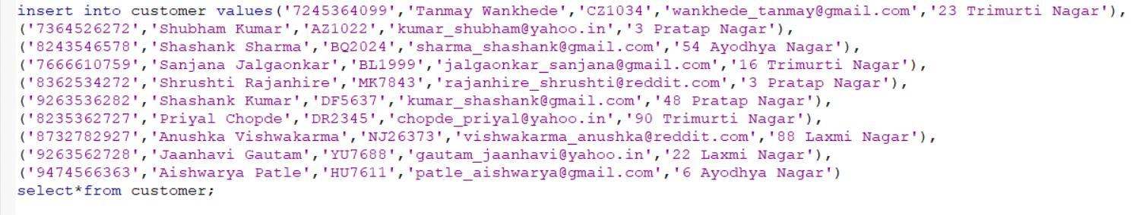

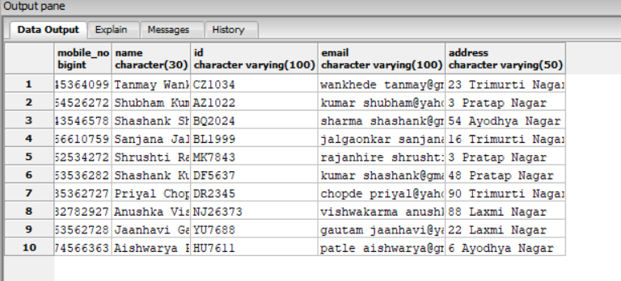

1. **Create Table Car_Owner**

insert into Car_owner values

('7245364099','TanmayWankhede','CZ1034'),

('7364526272','Shubham Kumar','AZ1022'),

('8243546578','Shashank Sharma','BQ2024'),

('7736628882','Tejal Tambe','BL1989'),

('8635356366','Ankita Kumar','WK4648'),

('9263536282','Shashank Kumar','DF5637'),

('8235362727','Priyal Chopde','DR2345'),

('8732782927','Anushka Vishwakarma','JI6473'),

('9646738827','Sanya Mathur','FG7383'),

('9474566363','Aishwarya Patle','HU7611')

select * from Car_owner;

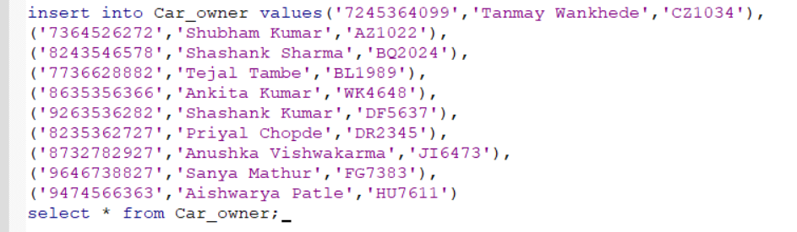

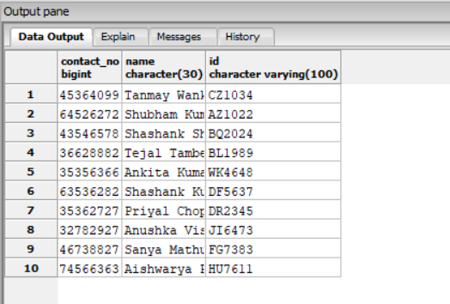

1. **Create Table Car_Model**

insert into Car_model values

('CM4647','1999','Audi'),

('CM3536','1999','Honda'),

('CM3636','2000','sharan'),

('CM6573','2020','polo'),

('CM4637','2018','Jeep volkswagen'),

('CM9546','2017','duster'),

('CM3674','1999','Car'),

('CM7743','2006','santana'),

('CM4372','2009','prius'),

('CM3547','2010','hilux')

select* from Car_model;

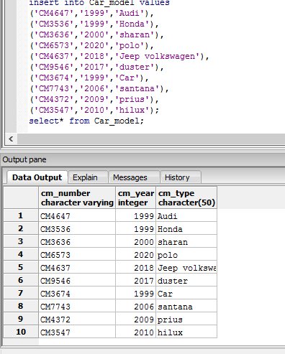

1. **Create Table User_info**

insert into user_info values

('TrimurtiNagar','8373827772','yadav_rahul@gmail.com','AM6473','Rahul'),

('ChatrapatiNagar','8398272766','mehra_mayur@yahoo.com','HK3638','Mayuri'),

('TrimurtiNagar','8363535578','mishra_sakski@gmail.com','HY3736','Sakshi'),

('AyodhyaNagar','7253566662','patole_anikita@gmail.com','JI8272','Ankita'),

('SwalambiNagar','8526267777','dhakaate_rajshri@hotmail.com','UY3627','Rajshri'),

('LaxmiNagar','8463625610','verma_rohit@gmail.com','IL3738','Rohit'),

('AyodhyaNagar','837362626','bhoyar_prem@gmail.com','HU7363','Prem'),

('LaxmiNagar','738272622','dharake_ankit@gmail.com','JY8675','Ankit'),

('SwalambiNagar','847566632','wagh_mayur@yahoo.in','HW7363','Mayur'),

('ChatrpatiNagar','735353572','malik_shital@gmail.com','JJ2722','Shital')

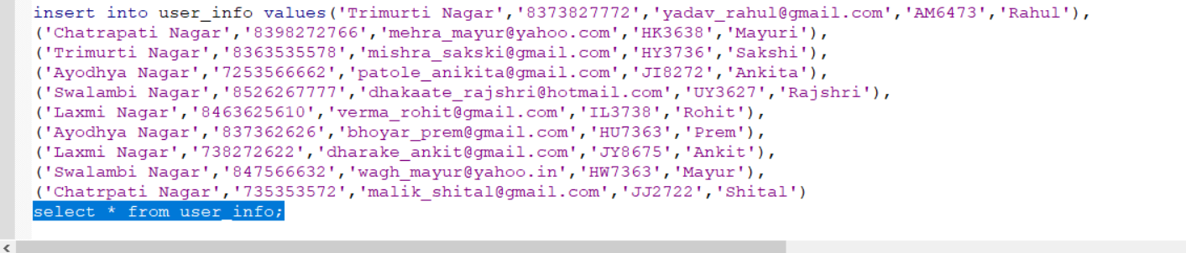

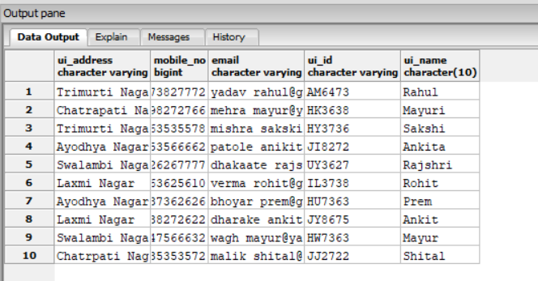

1. **Create Table Payment_type**

insert into payment_type values

(1,'Card'),

(2,'Cash'),

(3,'Cheque')

select* from payment_type;

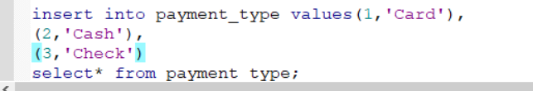

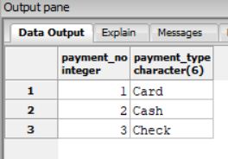

1. **Create Table Payment**

insert into payment values

('2','2222345','1'),

('3','460000','2'),

('1','1999999','3'),

('6','2838666','2'),

('9','600000','1'),

('7','1600000','1'),

('2','1000000','3'),

('1','400000','2'),

('5','700000','1'),

('9','1100000','3')

select * from payment;

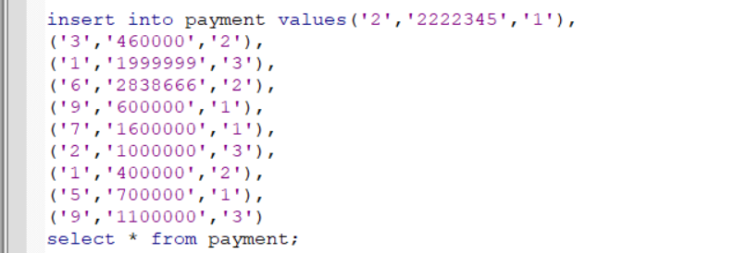

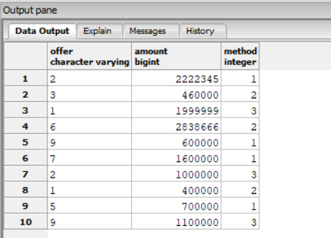

**PRACTICAL NO.5**

**Aim:** Data Retrieval from the designed database, e.g.

SELECT, Nested Queries

1.Find the information of ID who have done the payment using cheque method i.e. 3 rd option.

=Select * from payment;

Where method=’3’;

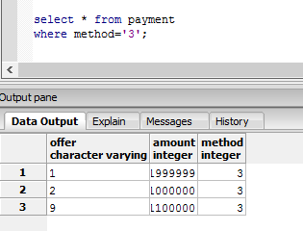

2. Find the information of customer whose name starts with S and the persons address is 3 pratap nagar.

=select * from Customer

where name like 'S%' and address = '3 Pratap Nagar';

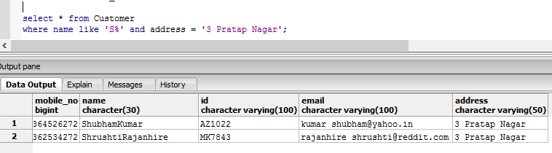

3.Find the ID and phone number of car owner whose name start with letter S .

=Select * from Car_owner

Where name like ’S%’;

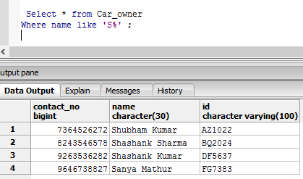

4. find the car type and number of car which is manufactured in 1999.

=Select * from Car_model

Where cm_year = 1999 ;

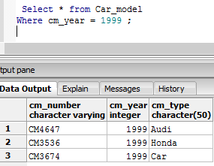

5. find the amount to be paid by customer through cash.

Select * from payment

Where method =’2’

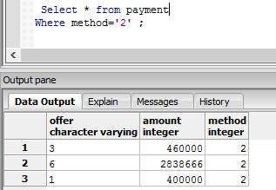

**PRACTICAL NO.6**

**Aim:** Data retrieval from the designed database. e.g. JOINS

(on CAR Showroom Management System)

* 1. Write a query to join two tables i.e. PAYMENT TYPE and Payment using inner join.

select *

from payment_type pt inner join payment p

on (pt.payment_no = p.Method)

order by payment_no**;**

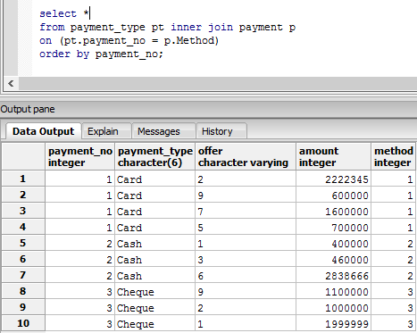

* 1. Write a query to join two tables i.e. . PAYMENT TYPE and Payment using left join.

select *

from payment_type pt left join payment p

on (pt.payment_no = p.Method);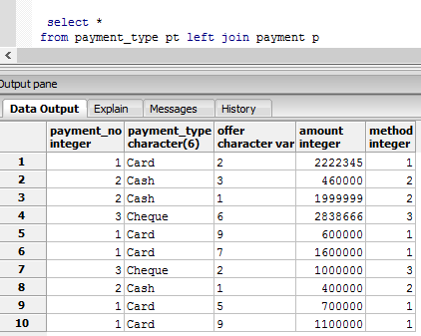

* 1. Write a query to join two tables i.e. payment type and payment using right join.

select *

from payment_type pt right join payment p

on (pt.payment_no = p.Method)

order by payment_no;

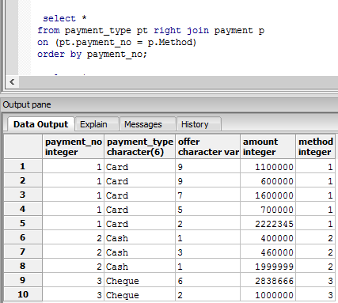

* 1. Write a query to join two tables i.e. payment type and payment using natural join**.**

select *

from payment_type pt natural join payment p;

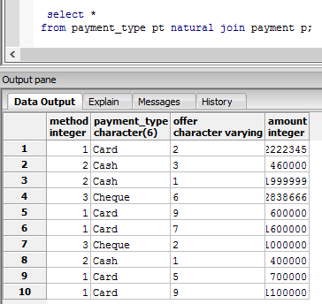

* 1. Write a query to join two tables using full join (i.e. right + left).

select *

from payment_type pt full join payment p

on (pt.payment_no = p.Method)

order by offer;

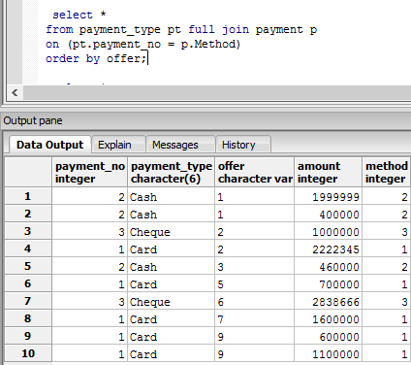

**PRACTICAL NO.7**

**Aim:** Search conditions, Summary queries, Sub- queries

(on Car Showroom Management System)

1) Display the id and names of staff who are client holders.

Query:

SELECT staff_id, staff_name

FROM Staff

WHERE staff_no IN(SELECT staff_no

FROM staff_type

WHERE staff_no = 2);

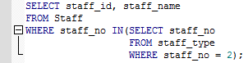

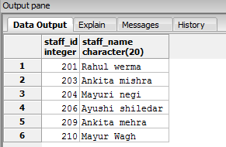

+2) Display the name, address, contact number of customers who has bought vehicles of ‘Honda’ brand.

Query:

SELECT first_name, last_name, address, contact_no

FROM Customer

WHERE Job_card_id IN(SELECT Job_card_id

FROM buying

WHERE brand_name like '%Honda');

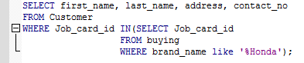

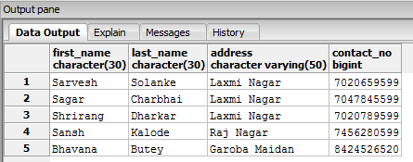

3) Display the costly vehicle that have been sold.

Query:

SELECT brand_name, model_name, vehicle_type, amount

FROM Buying

WHERE amount = (SELECT MAX(amount)

FROM buying);

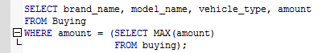

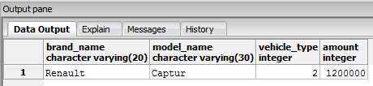

4) Display the name of customers who done payment through cash

Query:

Select first_name, last_name

FROM Customer

Where Job_card_id = ANY (SELECT Job_card_id

FROM payment

Where payment_method = 2);

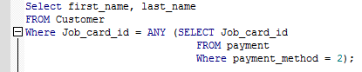

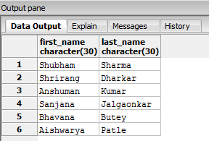

5) Display the prices of vehicles having amount greater than 1 lakh

Query:

SELECT brand_name,MAX(amount)

FROM buying

GROUP by brand_name

HAVING AVG(amount)>100000;



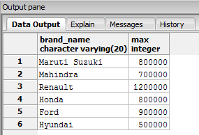

9) Display the list of female customers

Query:

SELECT first_name, last_name, Gender

FROM Customer

WHERE Gender = ALL (SELECT Gender

FROM Customer

WHERE Gender = 'F');

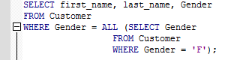

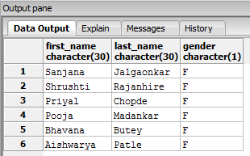

10) Display Customers count belongings to different address

Query:

select Address,count(Serial_No)

from Customer

group by Address;



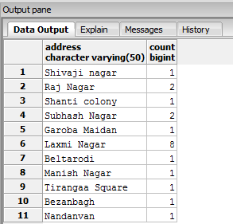

**PRACTICAL NO.8**

**Aim:** Transaction processing and Views

(On Car Showroom Management System)

1. Delete the record of Staff having id = 201.

Query:

begin;

select * from Staff;

delete from Staff where staff_id = 201;

commit;

select * from Staff;

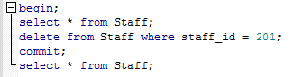

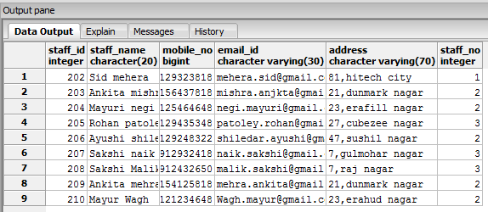

2. Delete all the customer’s record who are the belongings of laxmi nagar and rollback.

Query:

DELETE FROM Customer

Where Address = 'Laxmi Nagar';

SELECT * FROM Customer;

rollback;

SELECT * FROM Customer;

Before Rollback,

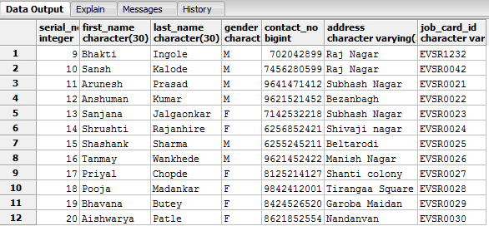

After Rollback,

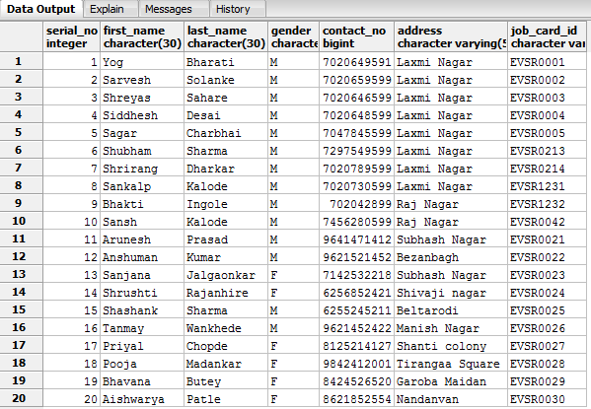

3. Update staff_no of Ayushi shiledar to 1(i.e, staff_type = sale head) create a save point and commit.

Query:

begin;

update Staff set staff_no = 1 where staff_name = 'Ayushi shiledar';

savepoint s1;

commit;

select * from Staff;

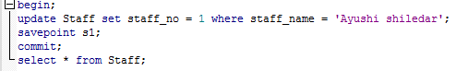

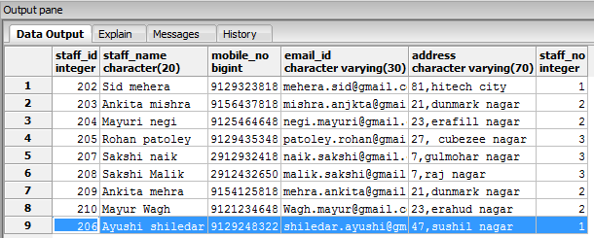

4. Update the address of customers as Swaraj Nagar in place of Raj Nagarand, delete the records having address as Subhash Nagar.

Use update, savepoint and release savepoint.

Query:

begin;

Update Customer set Address = 'Swaraj Nagar'where Address = 'Raj Nagar';

savepoint s2;

Select * from customer where Address = 'Swaraj Nagar';

delete from Customer where Address = 'Subhash Nagar';

savepoint s3;

select * from customer;

release savepoint s3;

rollback to s2;

select * from customer;

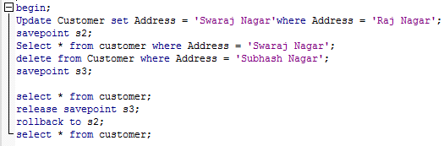

After savepoint s2,

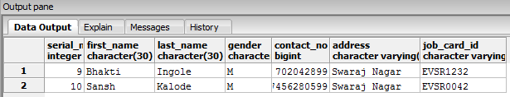

After savepoint s3,

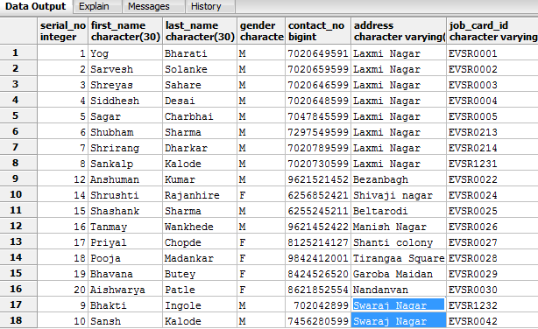

Conclusion

The Car showroom management system is developed using Postgres Sql with future support to allow its extensive expansion on the internet with dedicated client side as well as staff side. The framework for the data management has been established with the transaction detail’s storage and saving being functional. The system has a steady state where all bugs have been eliminated with the available functions. This system stands its high ground over others with its ability and operability to record data and process it. The staff will now be able to manage and hence run the entire work in a much better, accurate and error free manner.